Calculations

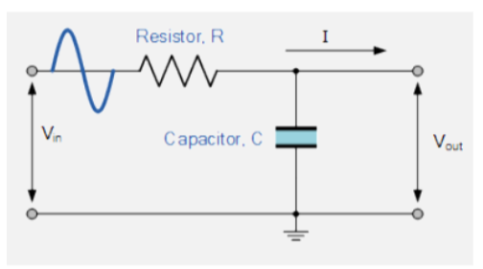
LC inductor
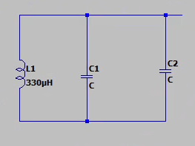
- need to have the right frequency- 10kHz
- L is 330mH
- F= ½*pi* sqrt(LC)
- Capacitors are two in parallel
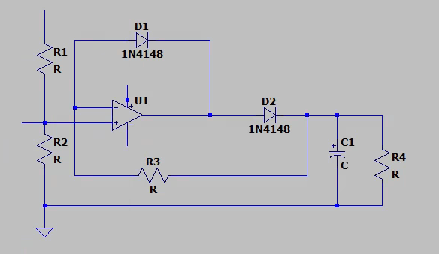
Rectifier values
Need resistor values R1 AND R2 to act as a potential divider
The diode is set
Capacitor I suppose is given
Resistors R3 and R4- who are they for
So R3 is I guess the feedback resistor? Essentially the one that’s across the diode and sets the slope of the voltage output graph
R4 is I assume for smoothing after
Fairly sure you want R2= R1, meaning res going in equal to R3, as when Rin=R3, the relationship beiween vout and vin in, is Vout= -Vin for -ve Vin- we want this
Need to work out:
- How the potential divider works
- What to set
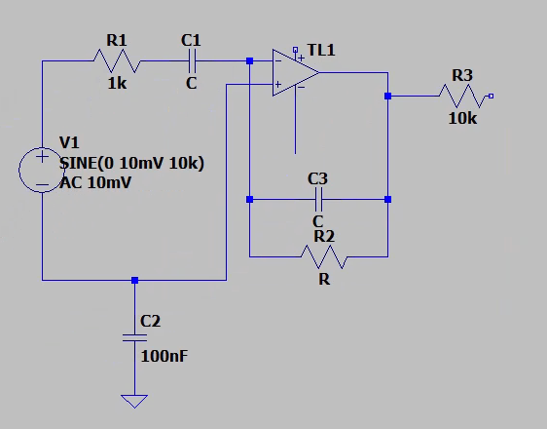
Opamp values
Gain?
- Only powered from single supply, needs DC offset added to +ve input, achieved using resistive pot divider circuit- research eq and suitable voltage applied to input
- Sets DC operating point of amplifier
- Unsure what the resistive potential divider is tbh
- Only need to work out R2 (R7 on actual) and capacitor values
- The opamp is a bandpass filter so need to use the resistor and capacitor values to determine what’s allowed through
- I guess that’s why you need the transient behaviour or smt idk I know the frequency coming in is 10 kHz so maybe it’s the -3dB point from there?
- -assuming that is correct, the low pass part and the high pass part both have the equation
$$f=1/2πRC$$
- The equations are in the big document
- Lower cut off – 3dB is fc1, upper is fc2
$$f_{C1}=\frac{1}{2πC_{5}R_{7}} \\ f_{C2}=\frac{1}{2πC_{1}R_{1}}$$
- Cut off of lower must be higher than the cut off of the high pass with a -3dB point determining bandwidth
- $C_{5}=\frac{1}{2πf_{C1}R_{7}}$
- $C_{1}=\frac{1}{2πf_{C2}R_{1}}$
- C1= 31.83X10-9
- C5=53.052X10-12

- R11 WAMTS TO BE EQUALT O THE RIN
- NEED TO GET RANGE TO 7.5KHZ TO 12.5KHZ
- ͳ =RC>> T=1/10kHz

